Chapter 3, Problem 22.

Determine v₁ and v₂ in the circuit in Fig. 3.71.

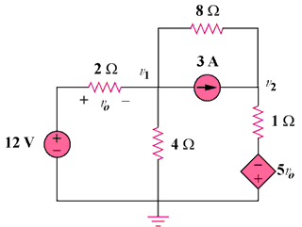

Figure 3.71
For Prob. 3.22.

